**Major Port Traffic and Capacity Analytics using IBM Cognos Analytics**

**A PROJECT REPORT**

**Submitted by**

**JIGYASA BISHT**

**19BAI10025**

in partial fulfilment for the award of the degree

of

**BACHELOR OF TECHNOLOGY**

in

**PROGRAM OF STUDY**



SCHOOL OF COMPUTING SCIENCE AND ENGINEERING

**VIT BHOPAL UNIVERSITY**

**KOTHRIKALAN, SEHORE**

**MADHYA PRADESH - 466114**

MAY 2022

**LIST OF FIGURES**

|  |  |  |
| --- | --- | --- |
| Figure No. | Title | Page No. |
| 1 | IBM Cognos Analytics Architecture | 6 |
| 2 | Flowchart | 7 |
| 3 | Port Wise Traffic Distribution | 8 |
| 4 | Port Wise Capacity Distribution | 8 |
| 5 | Port Wise Traffic vs Total Percent | 9 |
| 6 | Port Wise Traffic Projection vs Achievement | 9 |
| 7 | Port Wise Traffic Projection vs Achievement by Stacked Column Chart | 10 |
| 8 | Port-Wise Total Capacity Projects Vs Total Capacity Achieve by Line and Bar Chart | 10 |
| 9 | Port-Wise Traffic Projects Vs Total Projected by Area Chart | 11 |
| 10 | Port-Wise Total Capacity Achieve, Traffic Achieved Using Stacked Bar | 11 |
| 11 | Port-Wise Total Capacity Achieved Using Map | 12 |
| 12 | Summary | 12 |

**TABLE OF CONTENTS**

|  |  |  |
| --- | --- | --- |
| CHAPTER NO. | TITLE | PAGE NO. |
| 1 | INTRODUCTION  1.1 Overview  1.2 Purpose | 4 |
| 2 | LITERATURE SURVEY  2.1 Existing Problem  2.2 Proposed Solution | 5 |
| 3 | THEORETICAL ANALYSIS  3.1 Block Diagram | 6 |
| 4 | FLOWCHART | 7 |
| 5 | RESULT | 8-12 |
| 6 | ADVANTAGES AND DISADVANTAGES | 13 |
| 7 | APPLICATIONS | 14 |
| 8 | CONCLUSION | 15 |

**INTRODUCTION**

1.1 OVERVIEW

The Indian Railways has a capital base of about Rs. 100000 crores and is often referred to as the lifeline of the Indian economy because of its predominance in transportation of bulk freight and long distance passenger traffic. The network criss-crosses the nation, binding it together by ferrying freight and passengers across the length and breadth of the country. As the Indian economy moves into a high growth trajectory the Railways have also stepped-up developmental efforts and are preparing themselves for an even bigger role in the future.

The data we worked on had the following features:

|  |
| --- |
| Port |
| Traffic Proection |
| Traffic Achievement |
| Traffic Percentange |
| Total Capacity Projection |
| Total Capacity Achievement |
| Total Capacity Percentage |

1.2 PURPOSE

To regain some of the market, it has lost over past decades and regain market share in some commodities and overcome the challenges and to maintain sustainable growth in all its commodities.

Reducing the congestion on rail corridors and improving port connectivity.

The development of two Dedicated Freight Corridors across key ports.

In data we have a port, traffic & percent column. So, with the help of these plot a bar chart for showing no. of traffic various places are facing in the ports.

Bar chart to show the impression and spend, based on the ports.

To create dashboard using the data visualizations and export the analytics

**LITERATURE SURVEY**

2.1 EXISTING PROBLEM

➤ If we are finding unusual patterns within our data analysis or our statistical significance is not strong enough, we might not have enough data to make valid conclusions.

➤ Without doing data analysis, we won’t get the opportunity to evaluate the data before making actionable plans.

➤ Data is meaningless without context and without context, we cannot turn data into information.

➤ Information is useless without being able to apply to something

2.2 PROPOSED SOLUTION

➤ To create various data visualizations using IBM Cognos

➤ To make a dashboard using IBM Cognos

➤ Making dashboards can revolutionize both our success and enjoyment in running our business

**THEORETICAL** **ANALYSIS**

3.1 BLOCK DIAGRAM

IBM Cognos Analytics Architecture (High Level)

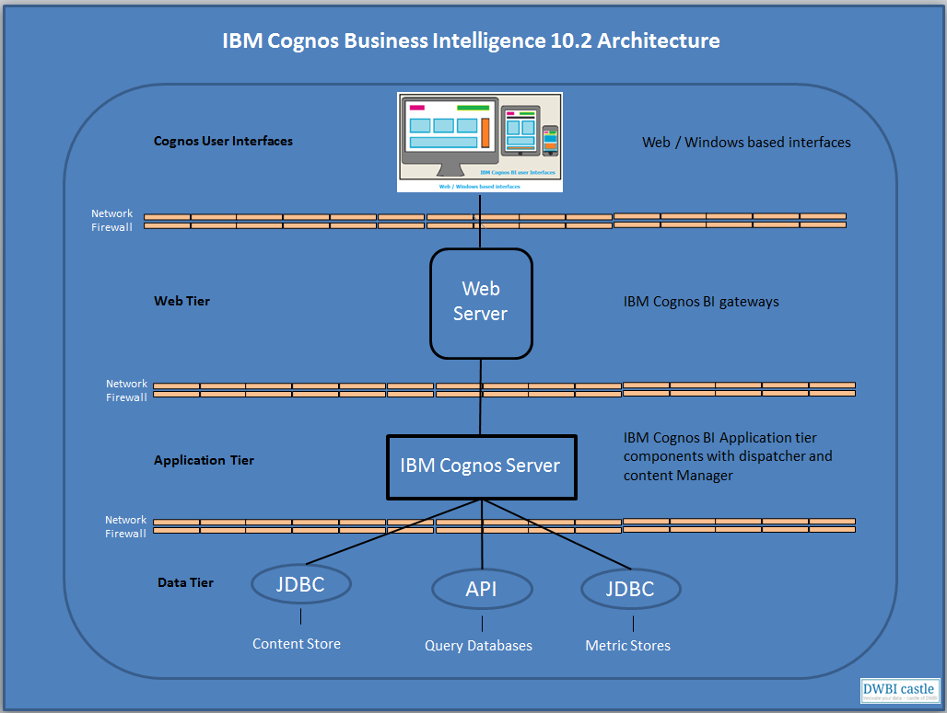

**FLOWCHART**

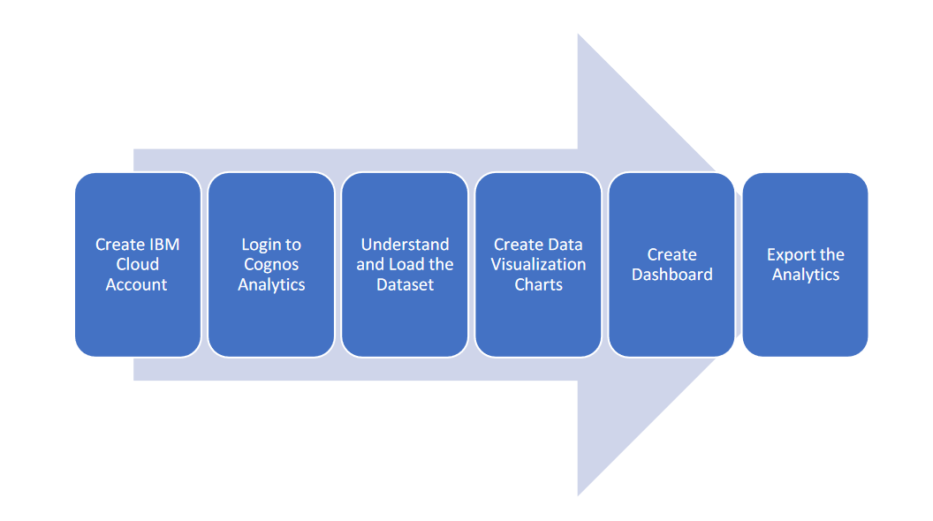

**RESULT**

5.1 Port Wise Traffic Distribution

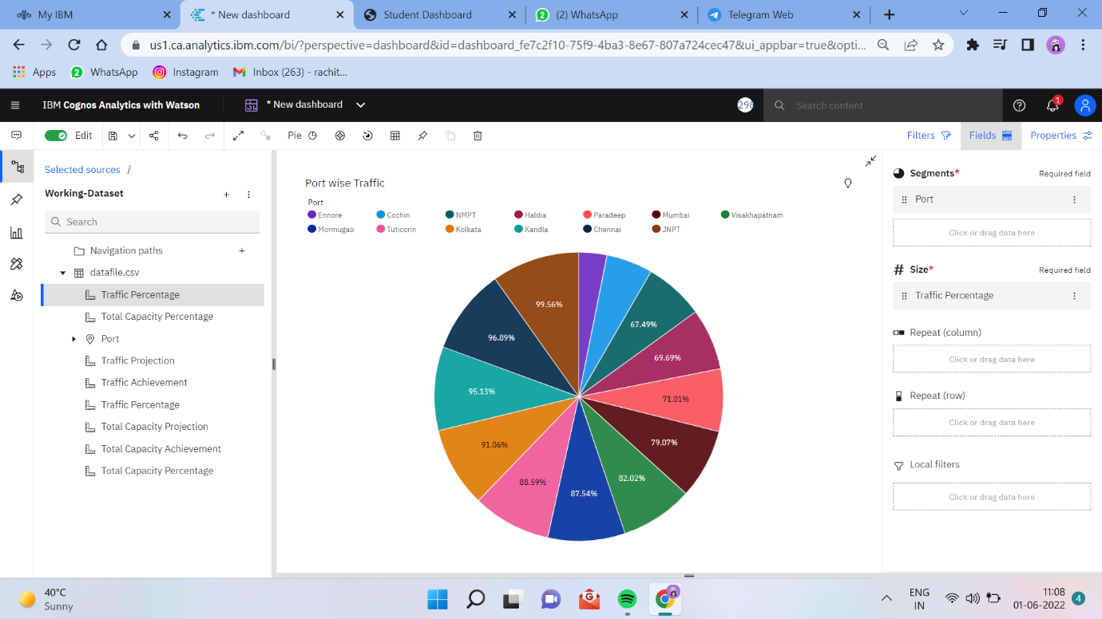

5.2 Port Wise Capacity Distribution

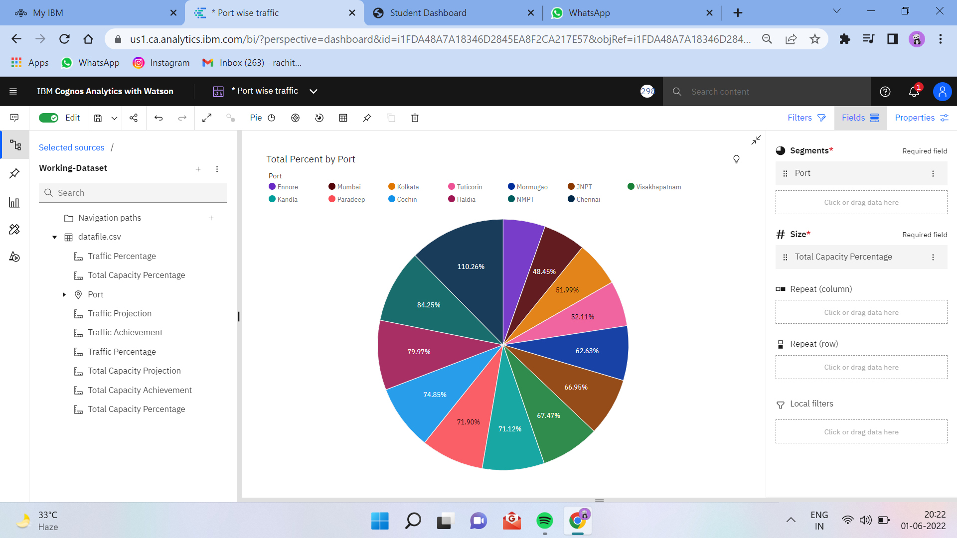

5.3 Port Wise Traffic vs Total Percent

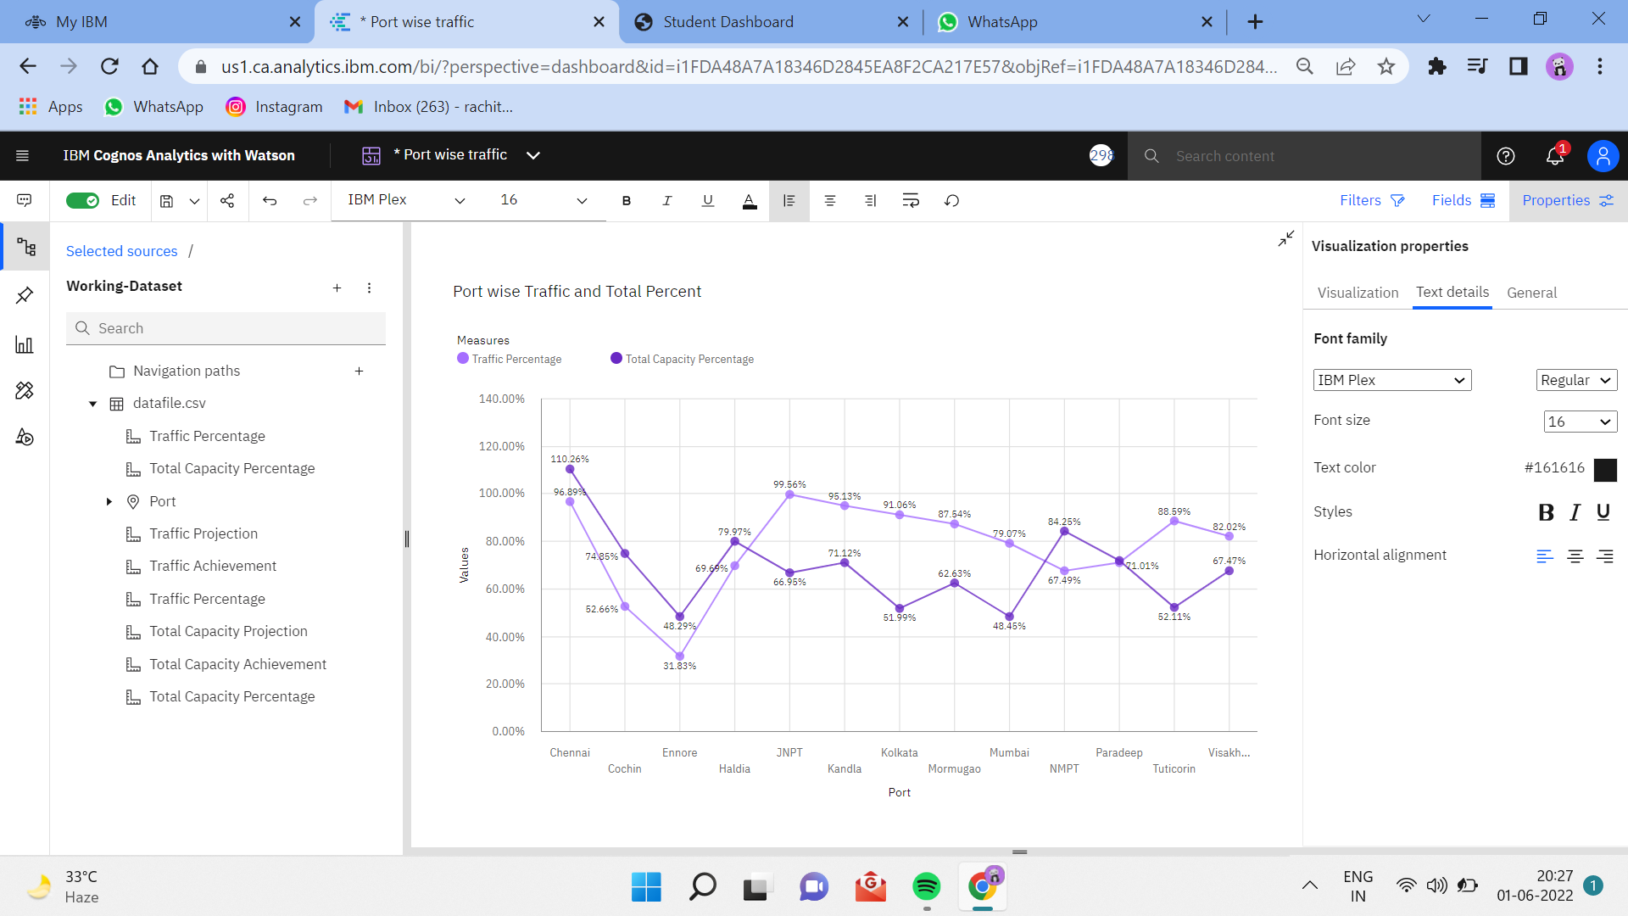

5.4 Port Wise Traffic Projection vs Achievement

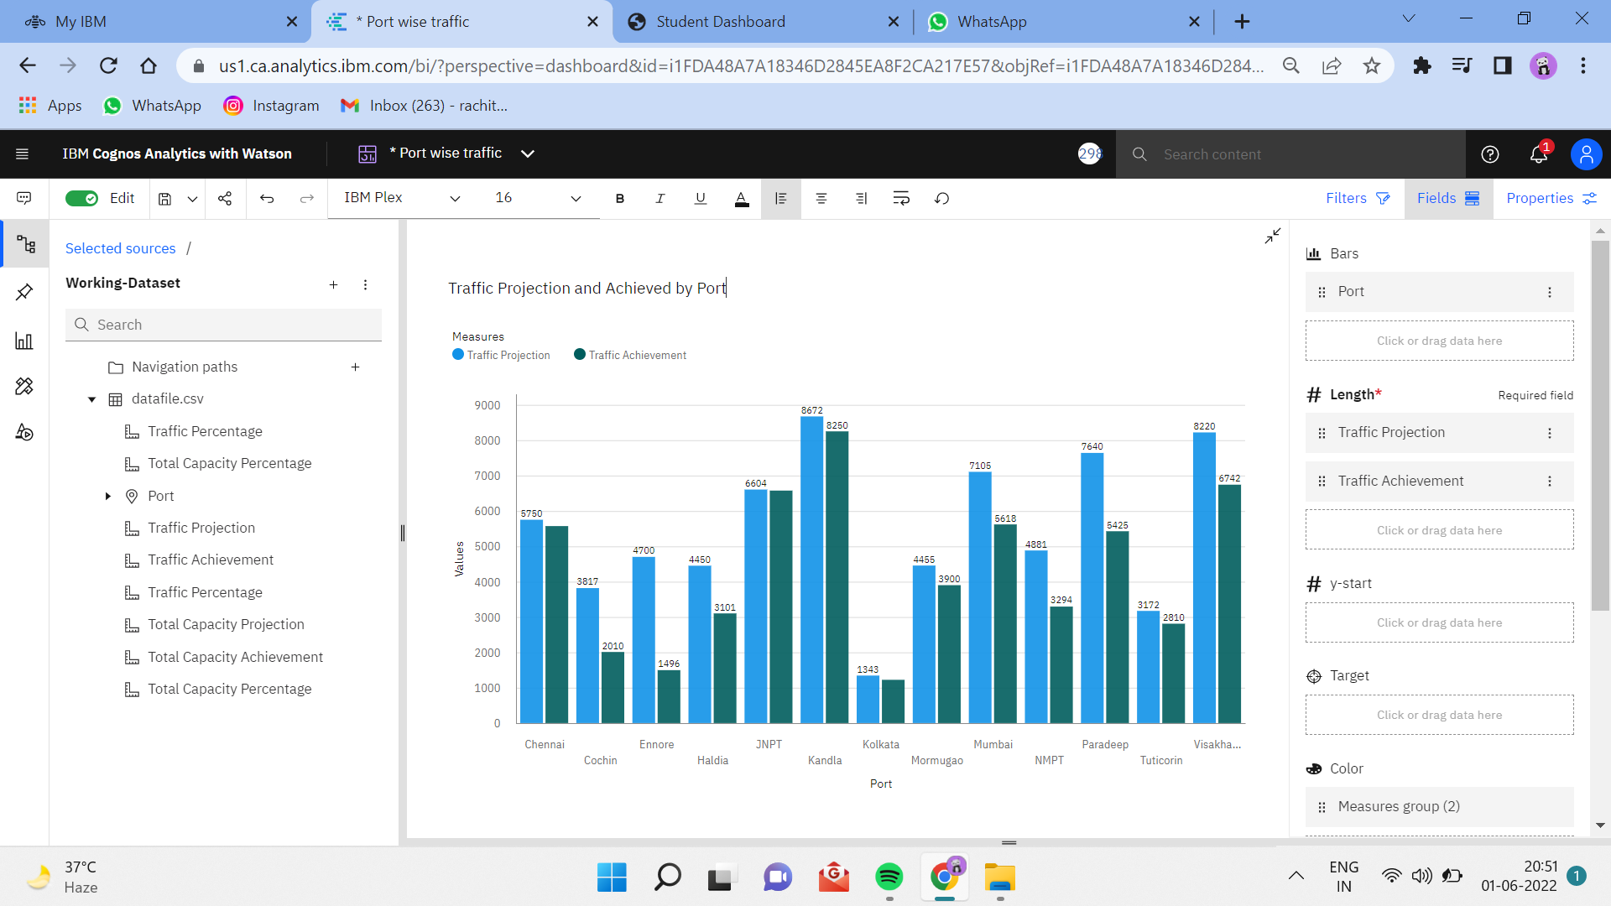

5.5 Port Wise Traffic Projection vs Achievement by Stacked Column Chart

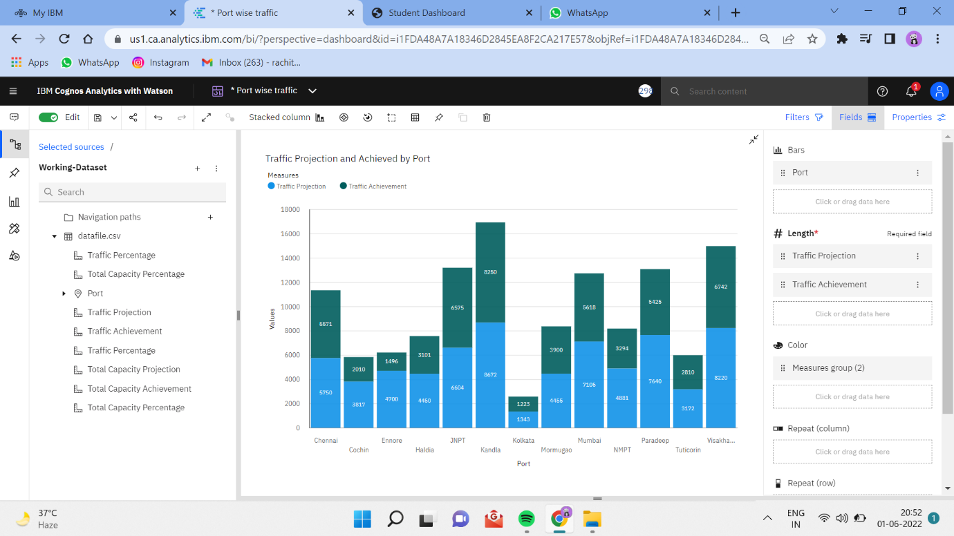

### 5.6 Port-Wise Total Capacity Projects Vs Total Capacity Achieve by Line and Bar Chart

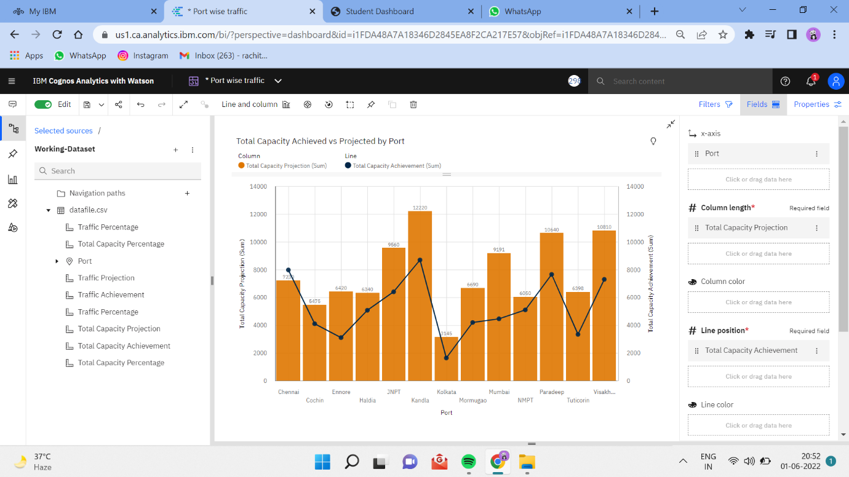

### 5.7 Port-Wise Traffic Projects Vs Total Projected by Area Chart

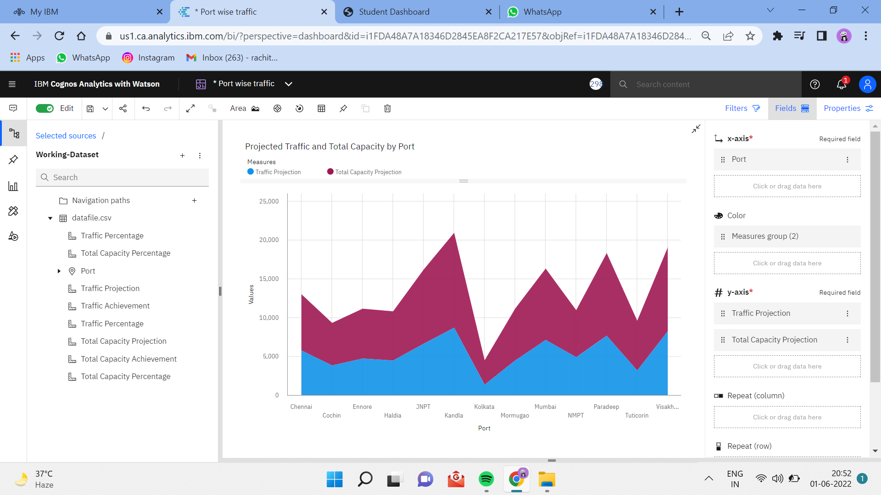

### 5.8 Port-Wise Total Capacity Achieve, Traffic Achieved Using Stacked Bar

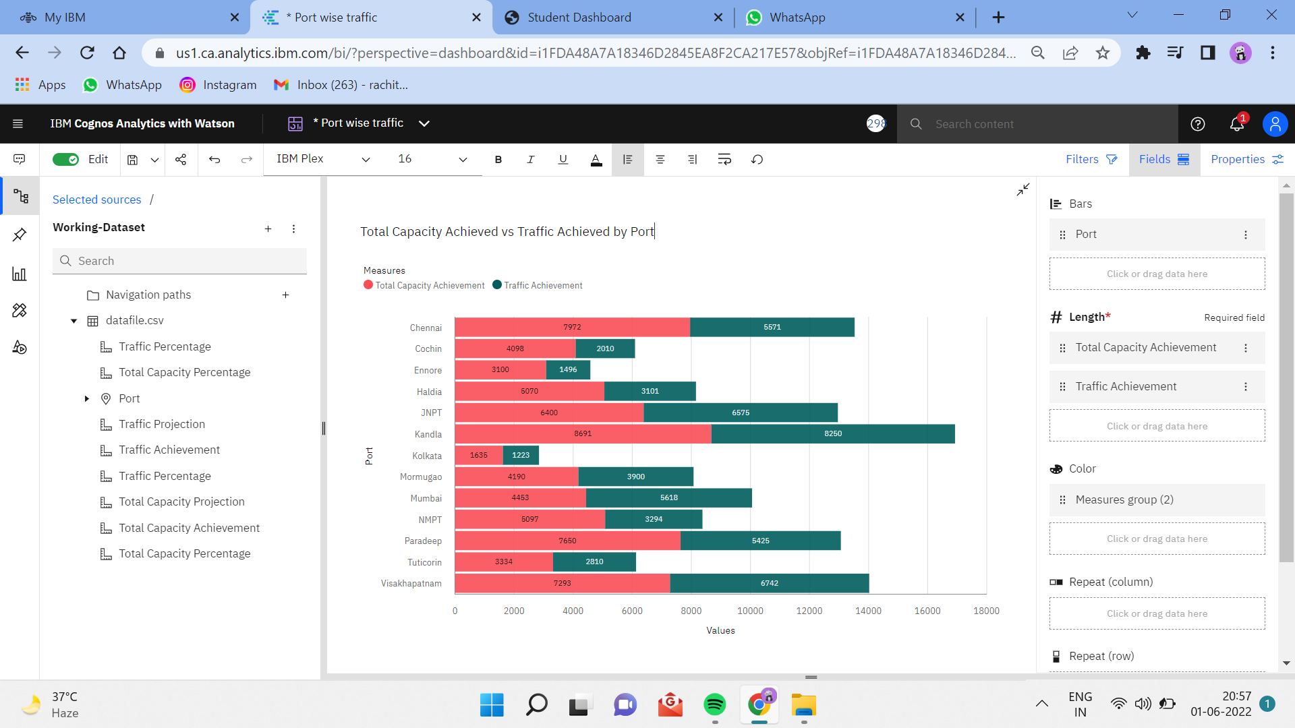

5.9 Port-Wise Total Capacity Achieved Using Map

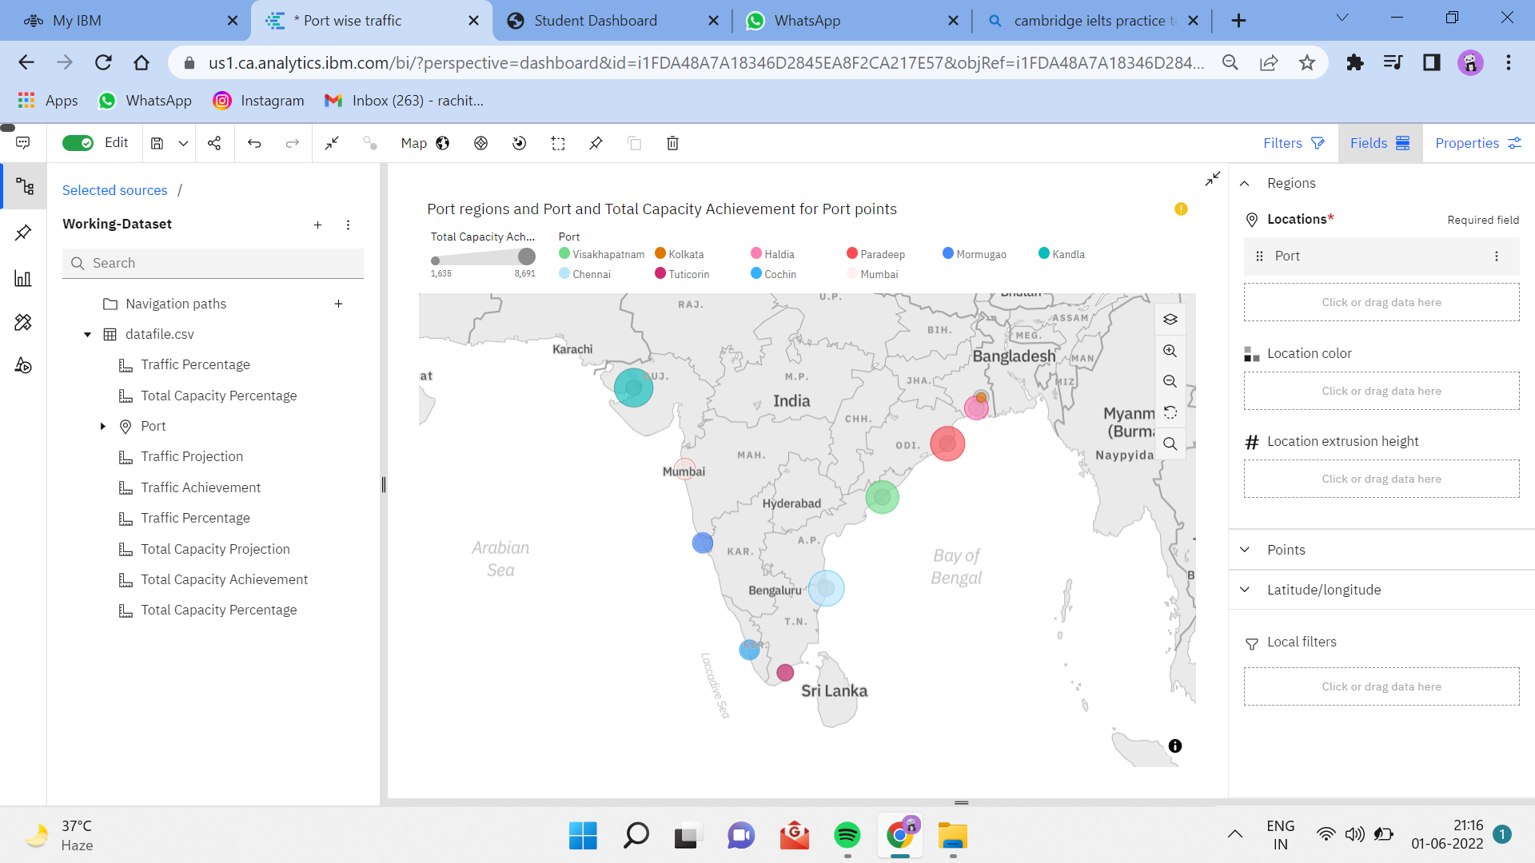

5.10 Summary

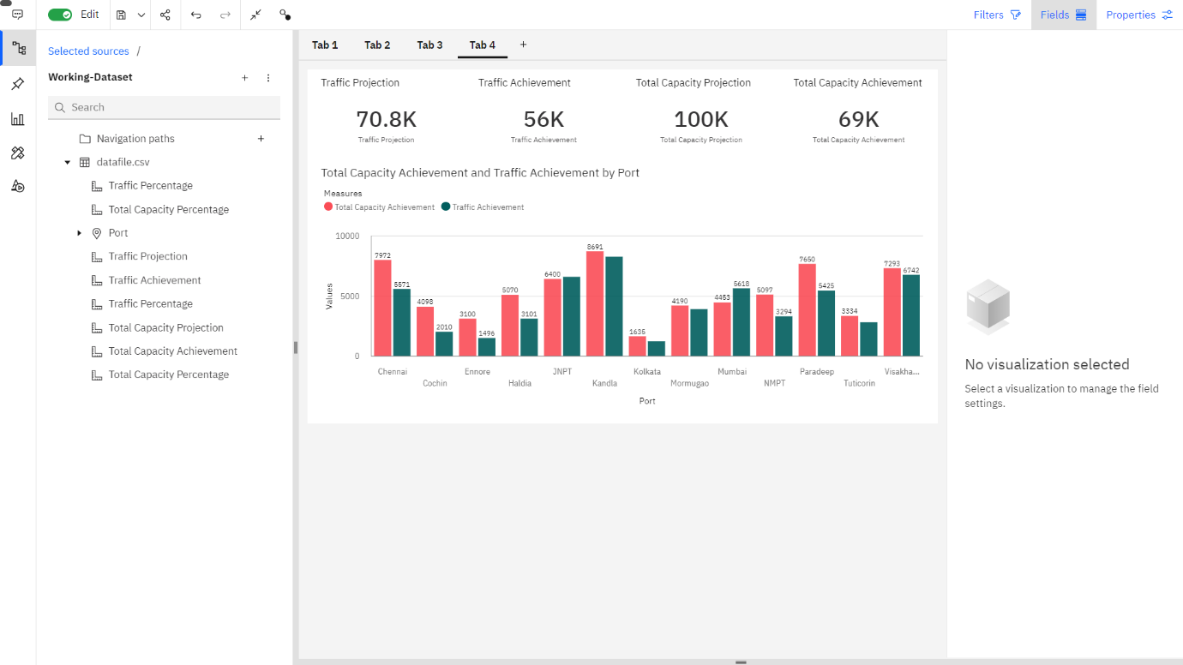

**ADVANTAGES AND DISADVANTAGES**

8.1 ADVANTAGES

➤ Enhanced Visibility: Dashboards provide greater visibility with information available whenever it is required to ensure businesses are better placed to respond to changing market conditions

➤ Time saving Efficiency: With dashboards, we are no longer wasting valuable time generating reports from multiple systems. Instead, data is drawn from a source and displayed as an easy to interpret visual overview.

➤ Better Forecasting: With greater insight into the data, future demand can be more accurately predicted using historic information. Businesses can be more effectively planned for demand fluctuations, setting measurable goals and deliverables for greater success.

➤ Better Decision Making: Whether you’re providing reporting and analysis for the entire organization or functional areas of the business, a dashboard allows companies to analyze key data quickly and meticulously. Visualized interactivity serves to deliver overwhelming amounts of data in a way that is easy to understand. With the ability to easily identify what the data really means; better decisions can be made relevant to the business.

8.2 DISADVANTAGES

➤ Flashy or cluttered design, with users attempting to incorporate too much information without understanding constraints or considering their specific needs from the range of different measurable detailed data analysis provides.  
➤ The technology used in the development of dashboards differs from other software solutions already employed in organizations and can be initially difficult to understand.

➤ The business has no predetermined rules and hierarchies for how dashboard metrics are used. This means each employee can use the metrics in different ways, resulting in a diverse set of data being reported.

**APPLICATIONS**

➤ If you manage complex campaigns, you usually end up having several analytics solutions for each platform and needing to consult them separately, which hinders the overall view. Instead, the dashboard displays data from different sources, like web analytics solutions, social media metrics. This way, makes it much easier to compare them and see how they develop.

➤ A good dashboard clearly shows you a number of key metrics so you don't need to be an analytics expert to understand them. If you want to look further into a particular data set, you always have the option of employing more specific tools.

➤ If you synchronize your dashboard automatically in the cloud, you can create different users so that your entire team can access the same information from anywhere. It's even possible to project the dashboard onto a screen in your office so that the whole team can see what is going on in real time.

➤ Having a centralized dashboard will save you a lot of time. Instead of collecting data from different sources and making charts on your own, dashboards do all this work for you. You just need to invest some time at the beginning to set up the metrics and decide how to present them. From that point on, the reports are created automatically.

**CONCLUSION**

From this project, we have successfully:

➤ Created multiple analysis charts / graph.

➤ Used the analysed chart creation of dashboard

➤ Saved and visualized the final dashboard in the IBM Cognos Analytics